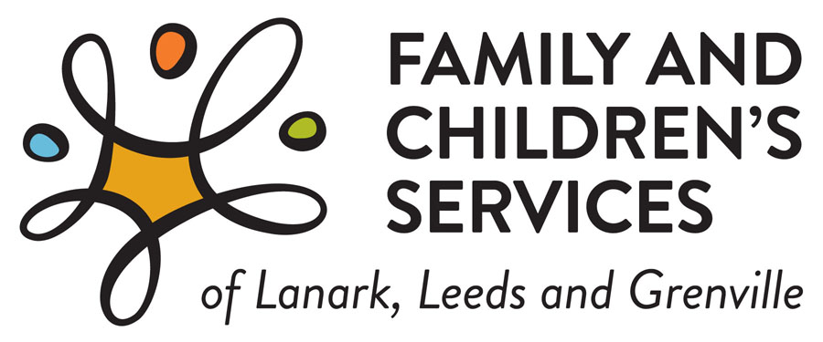

**Donate to our “Together for Our Kids” Fund!**

Family and Children’s Services is a child welfare agency mandated by the Child, Youth, and Family Services Act to provide child protection services to children and families in our counties. Our agency’s mission is to engage families and the community in the safety, permanency, and wellbeing of our children and youth. In carrying out our work, our vision is to foster engagement, inclusivity, and resilience for our families and young people we serve.

You can help us achieve those outcomes! Our core funding comes from the Ministry of Children, Community and Social Services, which funds the core services and administrative costs of the organization. Additional funding is required to provide crisis or supports to families, children and youth who may benefit from extra resources to meet basic needs or provide opportunities that other children and youth in the community might have.  Needs are often amplified during times of crisis.

Kinship service is a very important part of how we often keep children safe, yet there are often limited funds available for grandparents, aunts, uncles, neighbours to help them care for a child. Poverty is real, and while we cannot solve it as one agency, we would like to try and reduce as many barriers as possible and ensure that children in our Lanark, Leeds and Grenville communities have access to equitable opportunities and things they need when times can become tough, with as limited “red tape” or burden as possible.

**FCSLLG has a donation fund and we have used these dollars to provide extra support or unique opportunities for children and youth. Some examples include:**

* **FCSLLG has an annual snowsuit drive; every year donations are collected so that we can ensure hundreds of children are warm over the winter**
* **FCSLLG has an annual Angel Tree campaign to support children and youth so that they may have a special holiday season. Most of these donations come directly from community members but cash donations or gift cards are greatly appreciated to help families with extras during the holiday season**
* **FCSLLG runs a summer camp program. While we receive funds through the United Way of Leeds-Grenville, it is not enough to meet the needs across the counties**
* **assistance to families for exceptional needs (e.g., purchasing a stroller for parents with little children)**
* **episodic assistance for kinship families (e.g., purchasing a bed for a child, clothing)**
* **opportunities for youth that they might not otherwise have (trips for youth in care)**
* **sometimes we have provided emergency assistance for families to prevent an admission of a child to foster care (e.g., poverty should not be the reason for child welfare involvement, gas $ for appts, cards to deal with food security)**

Without sustained community donations, our ability to provide such assistance would be very limited. We rely on the generosity of community donors and United Way to run our camp program every summer. We want to do more for our families and children in the LLG community and hope you will consider donating today! Your contributions do make a difference and help to bring equity of opportunity to children and youth in our community.

Rurality is a real factor in Lanark, Leeds, and Grenville and sometimes it feels like we have to work harder to achieve our goals. So much of what we have accomplished is due to families helping families within our own local communities. Inter-connectedness within our communities is also extremely important, we are one organization serving the tri-county area. You can be assured that your donation will stay within Lanark, Leeds, and Grenville and your donation dollars will go directly to a family or a youth who needs assistance. FCSLLG is a registered charity and you may request a tax receipt upon donating.

**Thank you for donating today!**

**Please contact: Fiona Goodman at** [**fiona.goodman@fcsllg.ca**](mailto:fiona.goodman@fcsllg.ca) **or 613-498-2100 ext 4127**