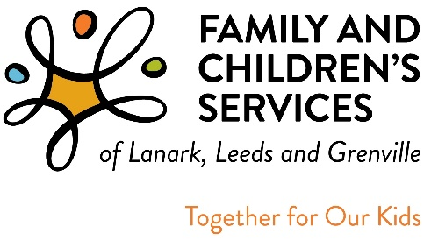

It’s that time of year again! FAMILY AND CHILDREN’S SERVICES OF LANARK, LEEDS AND GRENVILLE (FCSLLG) SEEKS INDIVIDUALS TO SERVE ON FCSLLG’S BOARD OF DIRECTORS

FCSLLG’s Vision Statement:
- Safe, healthy, resilient kids growing up in their families within their communities … where FCSLLG is part of a social system that promotes equitable outcomes for all children and families.

FCSLLG has been on a journey as an organization over the last couple of years to improve its provision of equitable and inclusive services for the families, children and youth we support. Please check out FCSLLG’s Statement of Equity https://youtu.be/6HorKlWHAJg

Within the last year, FCSLLG has engaged in the following activities to move our equity work forward, most notably:
- We have been collecting identity and demographic data about all the children and youth we serve. Notably, approximately 17% of our children and youth in care identify as Indigenous. Understanding who we serve will help us to deliver culturally appropriate services and ultimately address over-representation of populations in the child welfare system and the disparities of outcomes among marginalized children and youth who enter the system
- All our staff and Board members have been trained in Equity, Diversity, and Inclusivity concepts, including anti-oppression, Black and Indigenous racism, and its impact on the over-representation of marginalized groups in the child welfare sector, and we are dedicated to ongoing learning
- We understand that any progress on this journey involves strong, courageous, and humble leadership where we reflect on our work, challenge our assumptions, and work alongside families to achieve their goals for safety, permanency, and well being for their children. Regular reflections and unpacking of biases are an ongoing part of our leadership work
- We are reaching out to equity-seeking and deserving and marginalized groups to learn and share information so that our practice is informed by a variety of individuals and groups in our communities

Family and Children’s Services of Lanark, Leeds & Grenville (FCSLLG) – a Children’s Aid Society, is looking for new Board members who care about the children and youth of our community and want to make a difference by applying an equity seeking lens and anti-oppressive approach to the governance of the organization and the carrying out of its Mission and Vision to improve child, youth, and family outcomes.

FCSLLG seeks representation from the diversity of peoples and perspectives from across the counties of Lanark, Leeds and Grenville (LLG). We welcome all interested individuals, particularly representatives from equity seeking communities, including:
- Members from Indigenous communities, including First Nations, Inuit, Métis and Indigenous communities
- Members of the Black community and people of colour
- Individuals who identify as LGBTQ2S+
- Varied religious or spiritual faith groups
- Individuals with visible and invisible disabilities
- Other members of equity seeking or marginalized communities

If you have or desire the experience of...
- Serving on a Board of Directors;
- Representing community interests in a government funded professional organization;
- Developing strategic directions that promote service excellence;

Please contact Tammy Shepherd, Executive Assistant for more information at 1-855-667-2726, ext. 6288.

The Nominating Committee
c/o Tammy Shepherd
Executive Assistant to the Executive Director
Family and Children’s Services of Lanark, Leeds and Grenville
438 Laurier Blvd.
BROCKVILLE, Ontario K6V 6C5 or email us at info@fcsllg.ca

