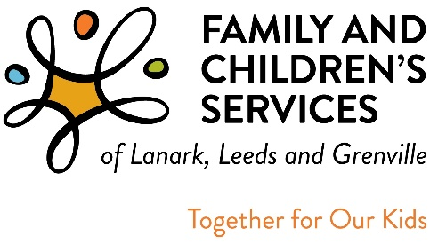

RECORD DATE NOTICE
(By-Law 4.2)
This is a general notice of FCSLLG’s Annual Meeting:
- Financial Report
- President’s and Executive Directors Report
- Election of Board of Directors

Only members of the Corporation as of the Record Date which is May 21st, 2023 will be entitled to vote at the Annual General Meeting.

Ms. Erin Lee Marcotte
Secretary to the
Board of Directors
c/o FCSLLG
438 Laurier Blvd.
BROCKVILLE, Ontario
K6V 6C5
1-855-667-2726

The Annual General Meeting of
Family and Children’s Services
of Lanark Leeds and Grenville
will be held on

Tuesday, June 20th, 2023

